Synopsis (ES 451)
On
Foundational Model Fine-Tuning
(Bring Your Own Data)
Submitted for partial fulfilment of award of the degree of
Bachelor of Technology
In
Computer Science & Engineering

Submitted by
Lakshit Verma – 12218002722
Abhishek Saurabh – 034180027222

Under the Guidance of
Ms. Shalini Singhal
Associate Professor

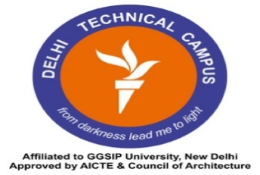

Department of Computer Science & Engineering

DELHI TECHNICAL CAMPUS, GREATER NOIDA

(Affiliated Guru Gobind Singh Indraprastha University, New Delhi)
Session 2025-2026 (ODD SEM)

